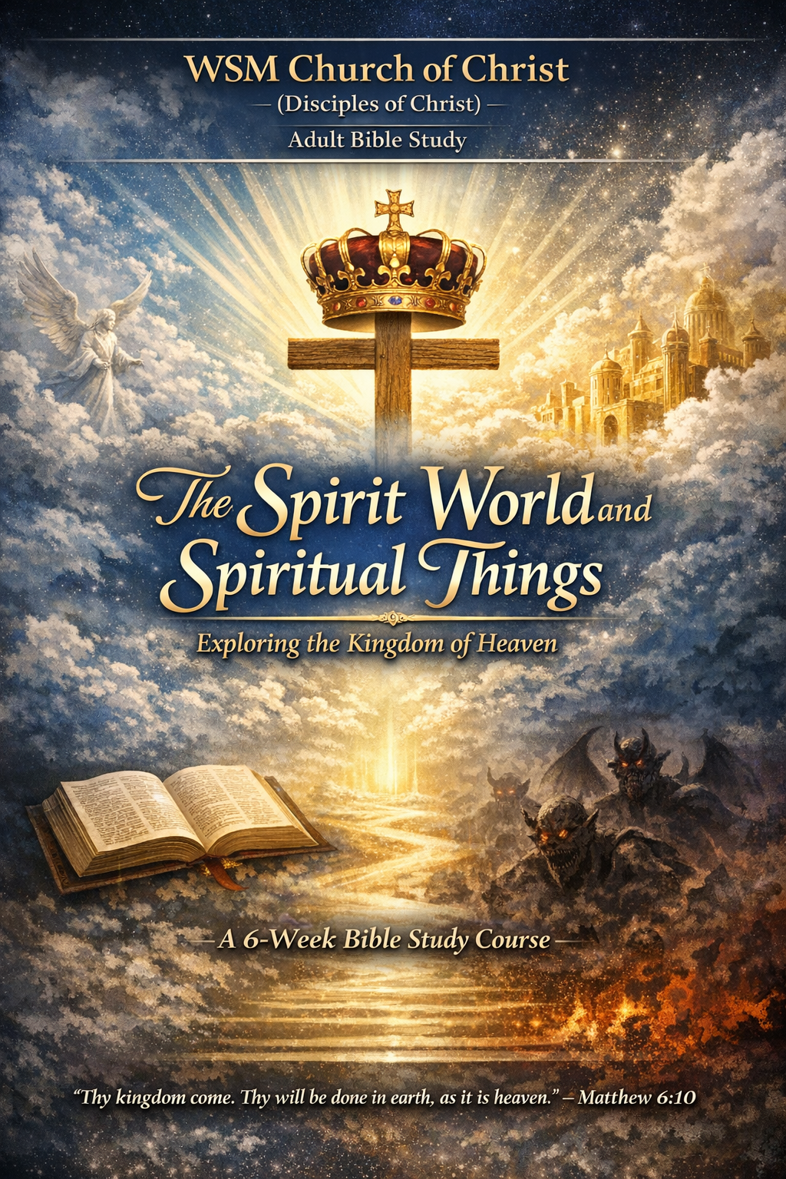
WSM Church of Christ (Disciples of Christ)
Adult Bible Study Course

Title: The Spirit World and Spiritual Things-Understanding the Kingdom of Heaven
Course Length: 3 Weeks
Instructor: Dr. Timothy Peppers

COURSE OVERVIEW
This course explores the biblical doctrine of the spirit world, emphasizing Jesus’ teaching on the spiritual Kingdom of Heaven, the nature of spiritual beings, discernment between truth and deception, and the believer’s life in the Spirit. Scripture from the King James Version (KJV) serves as the authoritative source.

WEEK ONE: THE REALITY OF THE SPIRIT WORLD & THE KINGDOM OF HEAVEN
Key Theme
The spirit world is real, eternal, and governs visible reality. Jesus taught that the Kingdom of Heaven is spiritual, not political or material.

Primary Scriptures (KJV)
- 2 Corinthians 4:18
- John 18:36
- Luke 17:20–21
- John 3:3

Lesson Explanation
1. The Unseen but Eternal Realm
“For the things which are seen are temporal; but the things which are not seen are eternal.”
— 2 Corinthians 4:18
Paul teaches that the visible world is temporary, while the unseen spiritual realm is eternal. This directly challenges modern materialism, which assumes only physical reality matters. Scripture affirms that spiritual truth of existence precedes physical existence.

2. Jesus’ Teaching on the Kingdom
“My kingdom is not of this world.” — John 18:36
Jesus rejected political or nationalistic expectations of the Messiah. His kingdom operates by spiritual authority, truth, and righteousness rather than force or geography.
“The kingdom of God is within you.” — Luke 17:21
This means the reign of God begins internally—within the heart transformed by faith.

3. Entrance into the Kingdom
“Except a man be born again, he cannot see the kingdom of God.” — John 3:3
Spiritual rebirth is required for spiritual perception. Without regeneration, the kingdom remains invisible and misunderstood.

Application
Believers must prioritize spiritual realities over worldly systems and understand that citizenship in God’s kingdom shapes how we live on earth.

Discussion Questions
- Why does Jesus emphasize the spiritual nature of the Kingdom of Heaven?
- How does spiritual rebirth affect how a person sees truth?

WEEK TWO: SPIRITUAL BEINGS, DISCERNMENT, AND DECEPTION
Key Theme
God rules the spirit world, but Scripture warns of both holy and fallen spiritual beings. Discernment is essential.

Primary Scriptures (KJV)
- John 4:24
- Hebrews 1:14
- Ephesians 6:12
- Mark 8:18
- 1 John 4:1

Lesson Explanation
1. God as Spirit
“God is a Spirit: and they that worship him must worship him in spirit and in truth.”
— John 4:24
God’s nature is spiritual, not physical. True worship must align with His nature, not human tradition or emotion.

2. Angels and Demonic Forces
“Are they not all ministering spirits…?” — Hebrews 1:14
Angels serve God and assist believers, but they are never objects of worship.
“We wrestle not against flesh and blood…” — Ephesians 6:12
Spiritual warfare is real. Conflict often appears human but originates in the spiritual realm.

3. Spiritual Blindness
“Having eyes, see ye not?” — Mark 8:18
Jesus rebuked those who could see physically but lacked spiritual understanding.

4. Testing the Spirits
“Try the spirits whether they are of God.” — 1 John 4:1
Not all spiritual experiences are from God. Discernment requires Scripture and submission to Christ.

Application
Believers must avoid fear and superstition while remaining alert to deception. Truth is found in Christ alone.

Discussion Questions
- Why is discernment essential for spiritual maturity?
- How does Scripture protect believers from deception?

WEEK THREE: FALSE SPIRITUAL PRACTICES, THE HOLY SPIRIT, AND CHRISTIAN LIVING
Key Theme
True spirituality is Christ-centered and Spirit-led, not mystical or self-directed.

Primary Scriptures (KJV)
- Deuteronomy 18:10–12
- Romans 1:25
- Acts 1:8
- John 16:13
- Romans 8:11

Lesson Explanation
1. Forbidden Spiritual Practices
“There shall not be found among you… a consulter with familiar spirits…”
— Deuteronomy 18:10–12
God forbids occult practices because they seek power apart from Him.
“Who changed the truth of God into a lie.” — Romans 1:25
False spirituality replaces worship of God with created things or human wisdom.

2. The Holy Spirit’s Role
“Ye shall receive power, after that the Holy Ghost is come upon you.”
— Acts 1:8
The Holy Spirit empowers believers to live, witness, and grow in holiness.
“He will guide you into all truth.” — John 16:13
Truth is not discovered through experimentation but revealed by the Spirit.

3. Living Spiritually Aware Lives
“If the Spirit of him that raised up Jesus… dwell in you…”
— Romans 8:11
Christian life is sustained by the Spirit, not human effort.

Application
True spirituality produces obedience, humility, holiness, and Christlikeness—not confusion or pride.

Final Reflection Assignment
Write a 200-word reflection answering:
How does understanding the spirit world and the Kingdom of Heaven shape your daily walk with Christ?

COURSE CONCLUSION
Jesus revealed the unseen world not to inspire fear, but faith. The Kingdom of Heaven is present now, advancing through transformed lives until its final consummation. True spiritual life is found only in Christ, through the Spirit, according to God’s Word.

